Name
Prof
Institution
International Economics Test 3
May 9, 2021.
Question One a.
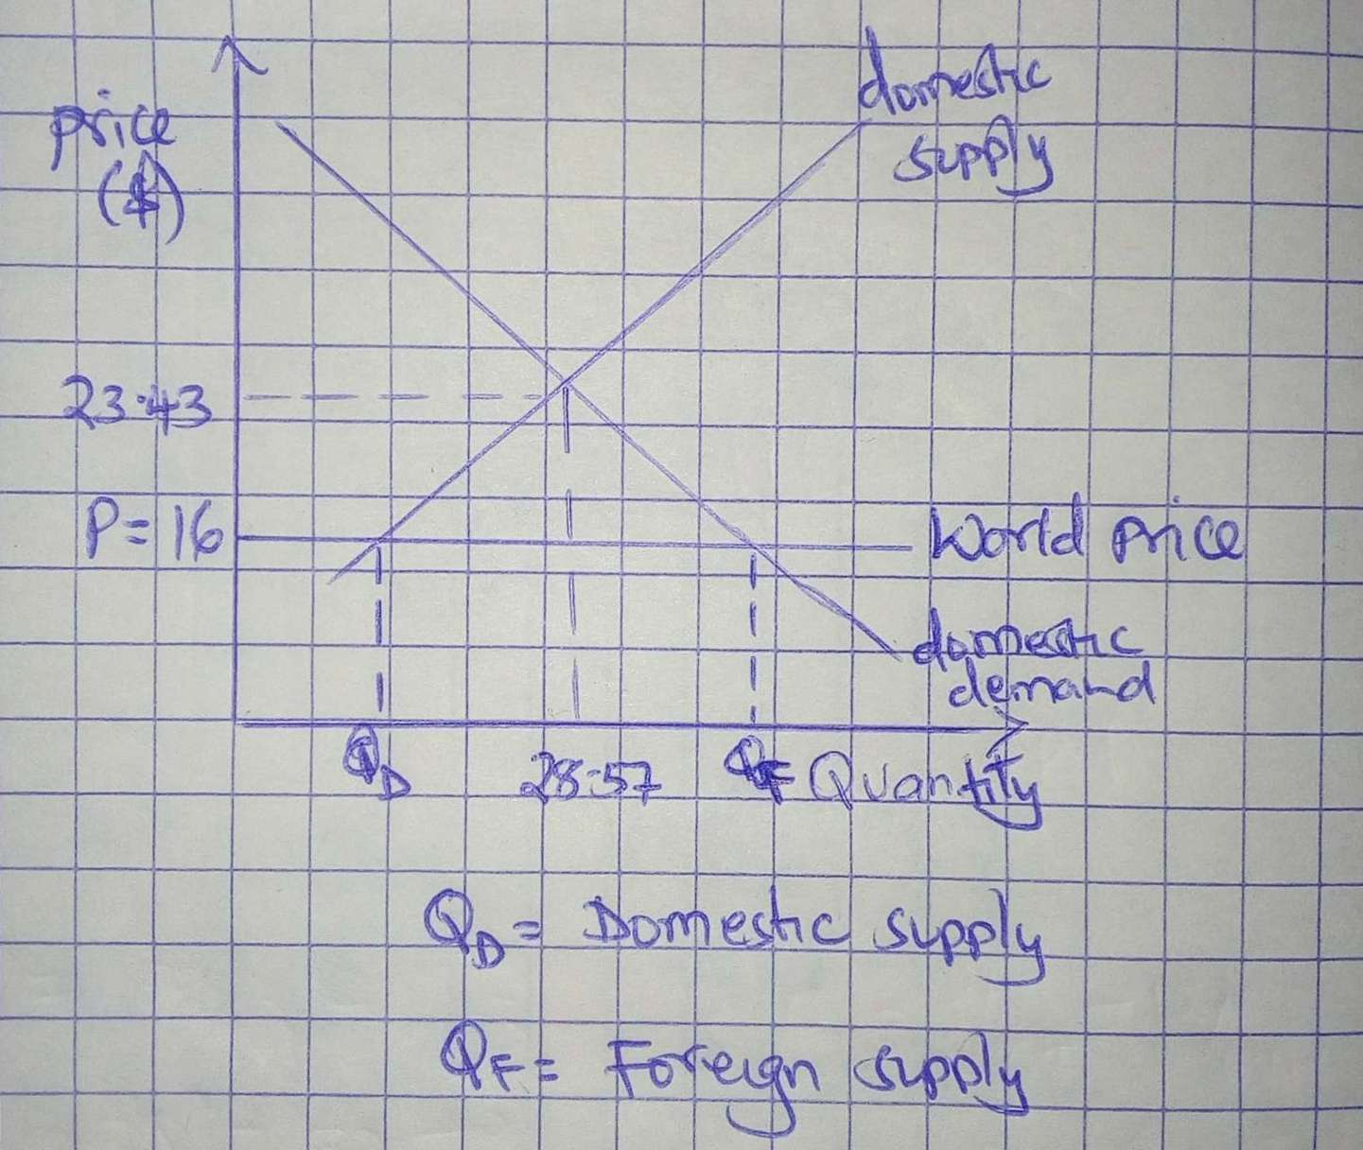
Figure 1.0
b and c
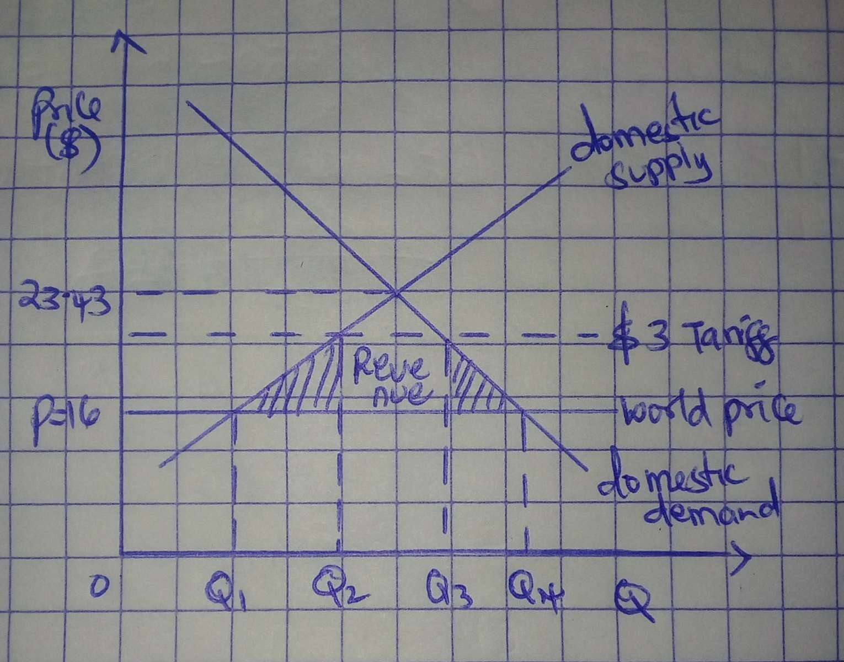
Figure 1.1
d.

Figure 1.2
e. Deadweight loss is the shaded area in figure 1.1

Question two
Tariffs are important intervention tools by the government to protect the domestic economy from unhealthy competition from the international markets. It helps preserve the competitiveness of local industries and protects the jobs in the domestic economy.
Nevertheless, tariffs have costs associated since domestic consumers have access to a variety of goods and services following the high prices of foreign goods relative to domestic goods.

Question Three
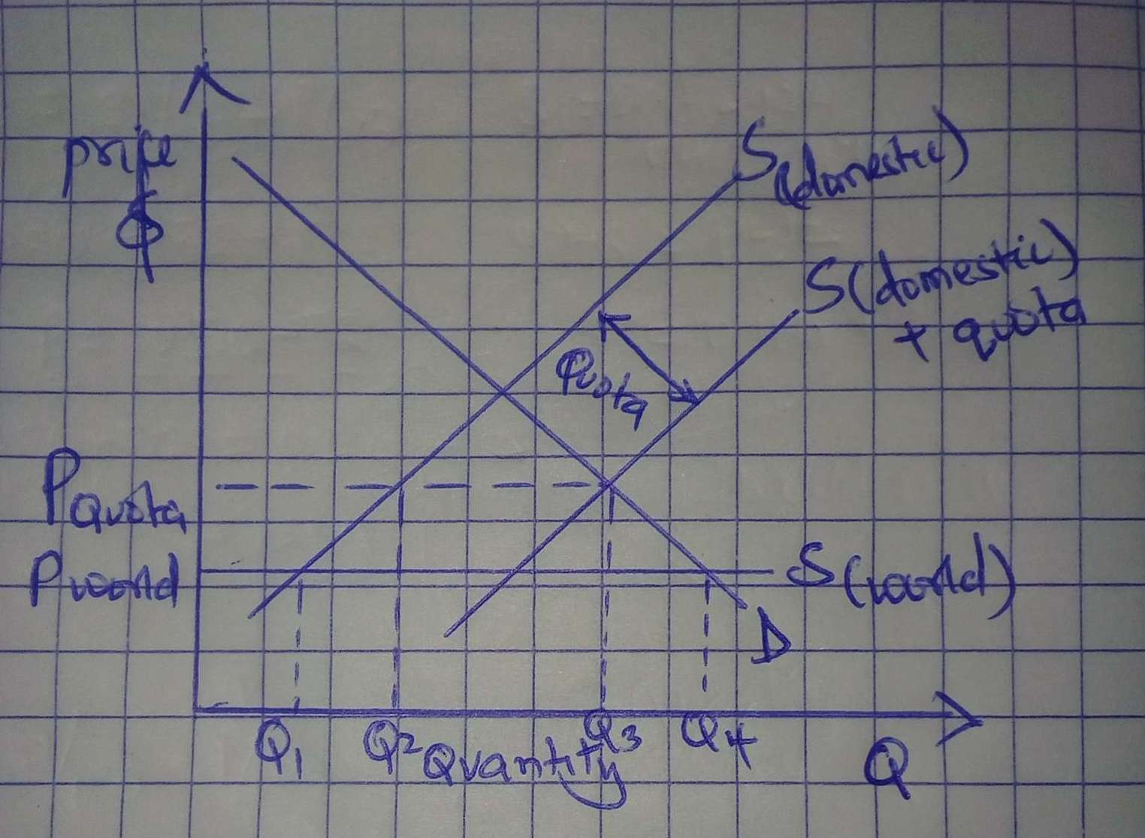
Figure 3.0
Question four
a.
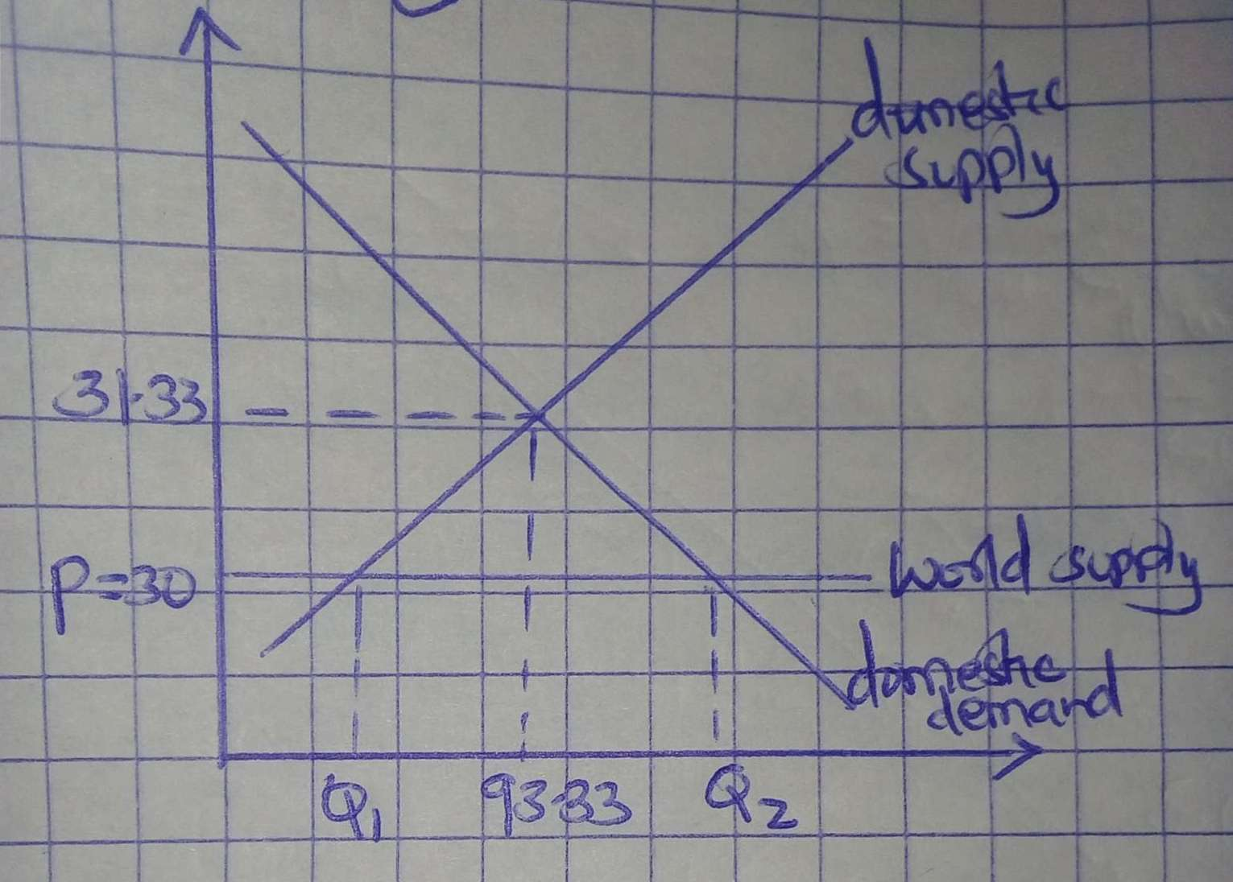
Figure 4.0
b
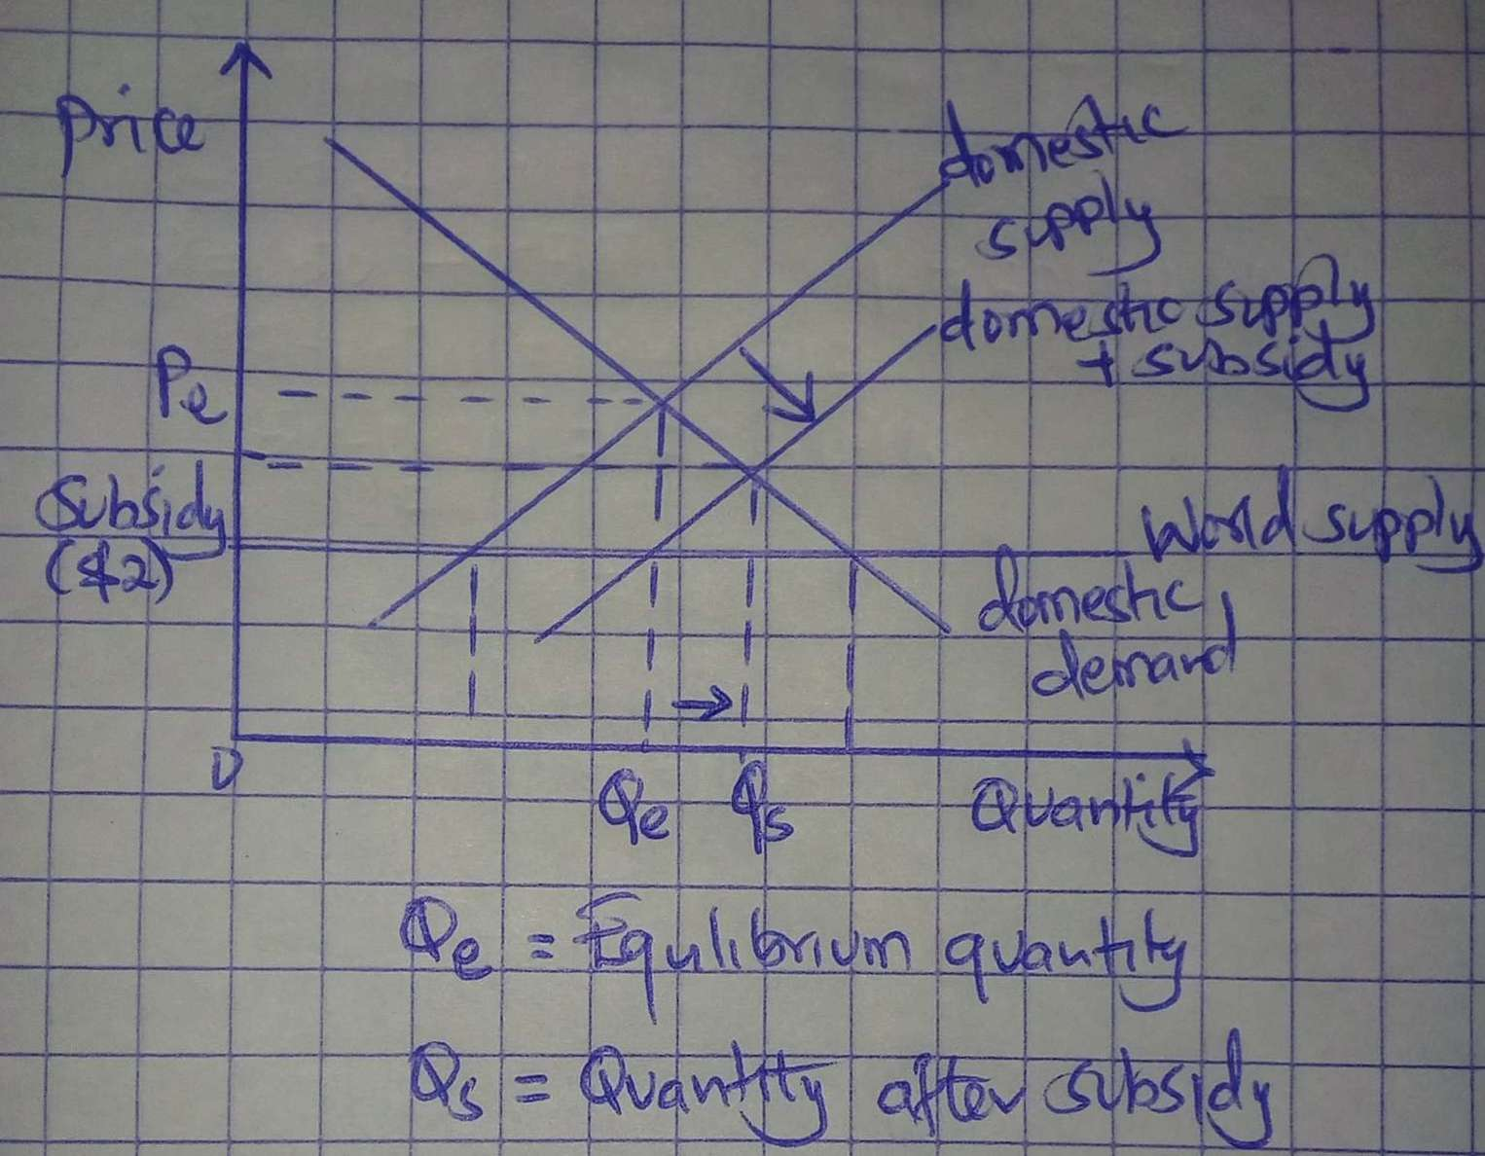
Figure 4.1
c.

Figure 4.2

Question Five
a.
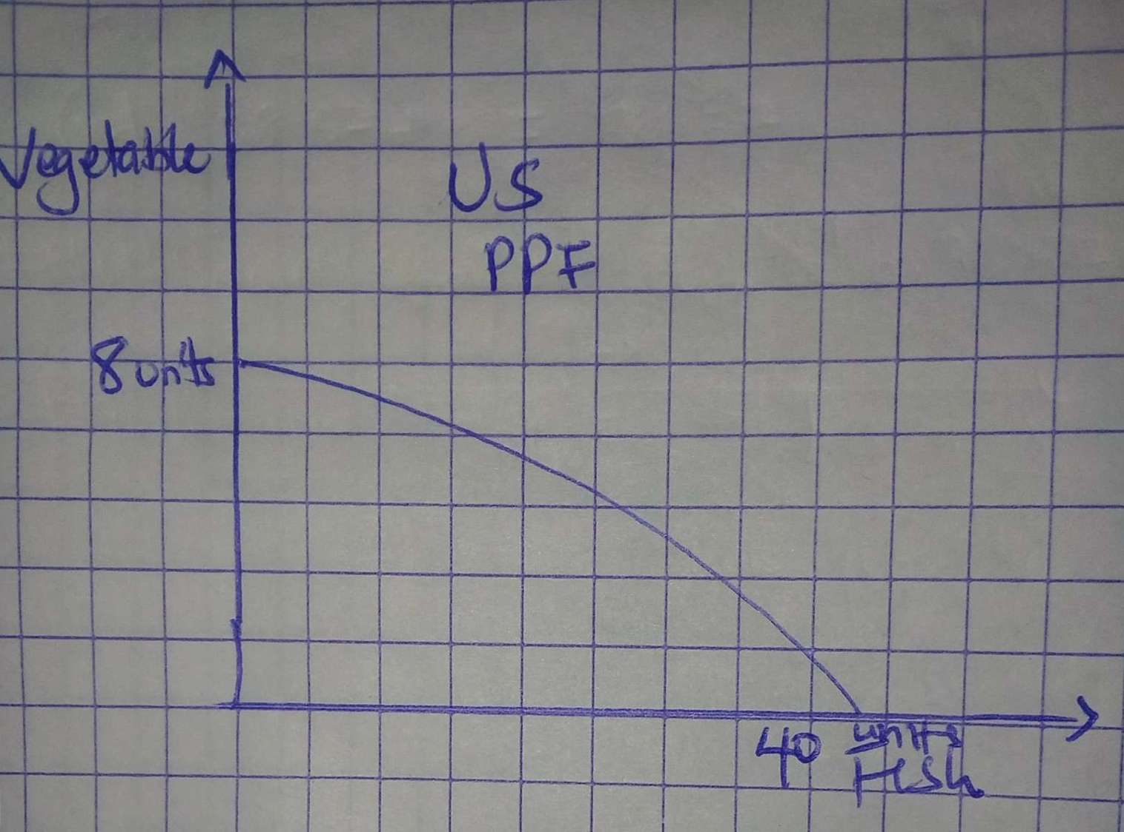


Figure 5.0
b
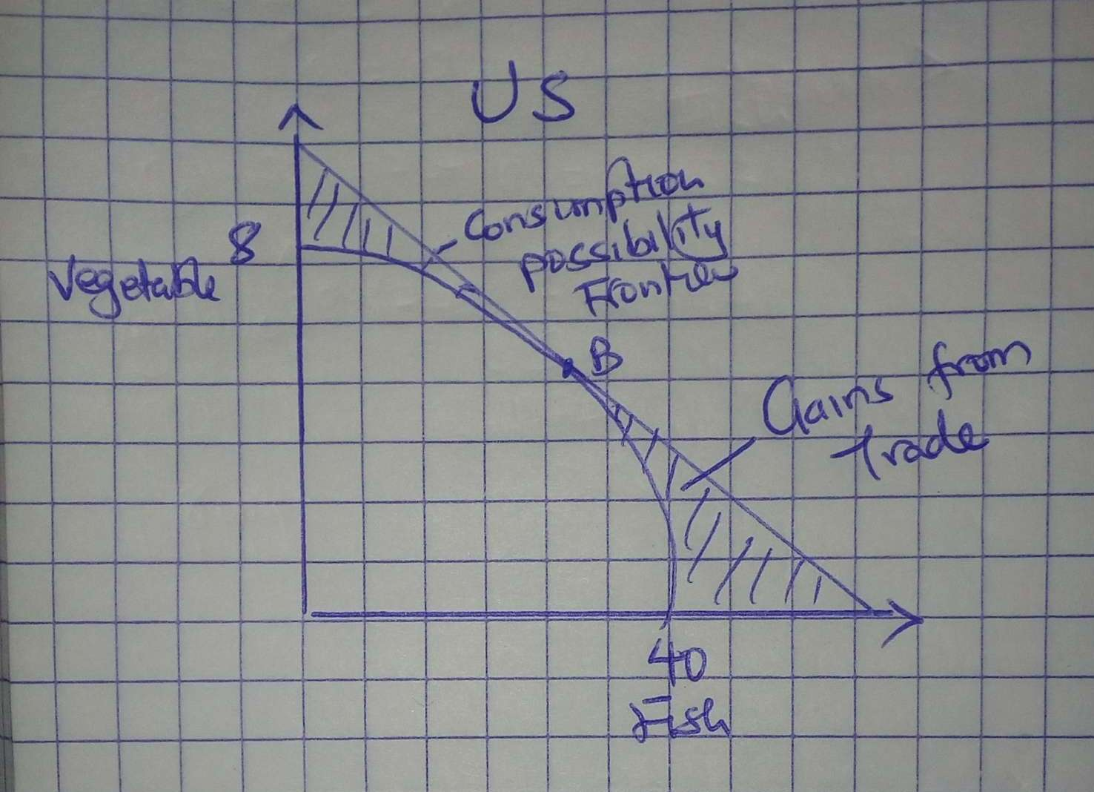
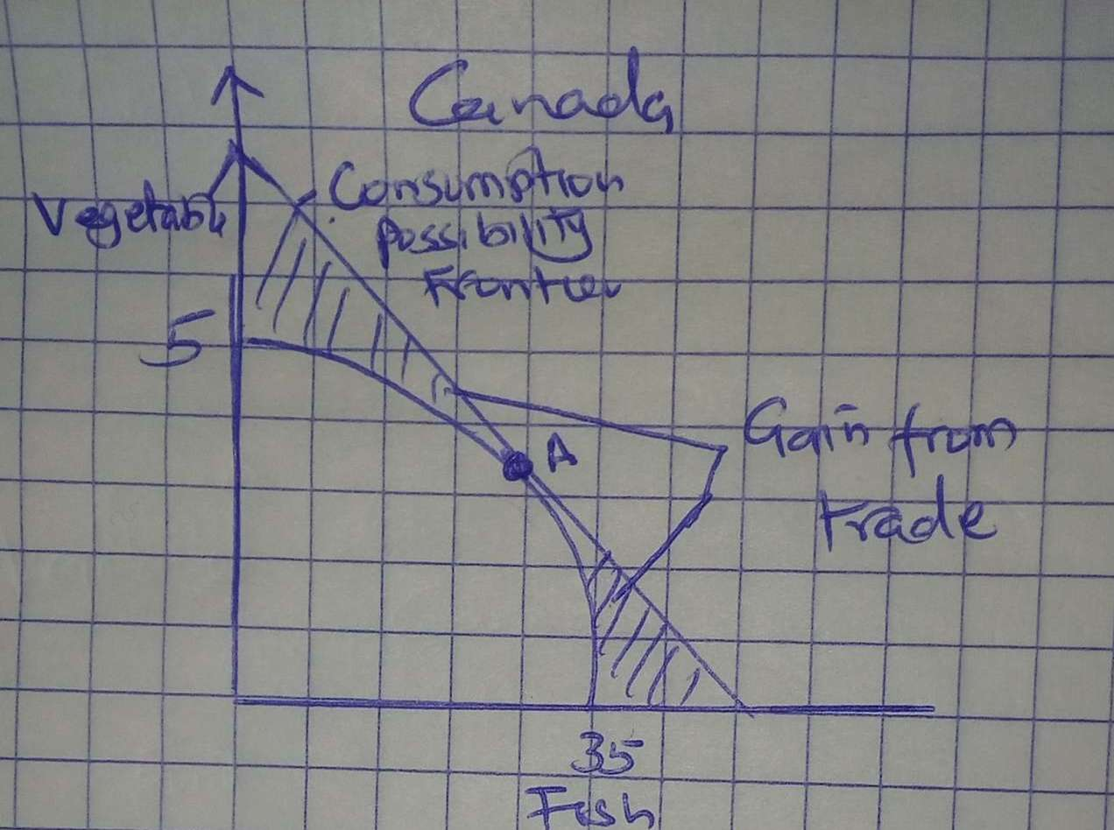
Figure 5.1

Question Six
The United States is relatively more labour abundant than Canada. This is because the capital-labour ratio of Canada is 0.2 compared to that of the US, which is 0.17
Canada is a relatively capital incentive because it has a higher capital per worker compared to Canada. For every One machinery, there are five workers.
- Steel is relatively capital intensive, while bread is relatively labour intensive. The steel machine per worker is 0.25 while for bread it is 0.125.
- The United States would export bread because it is relatively labour intensive

Question Seven
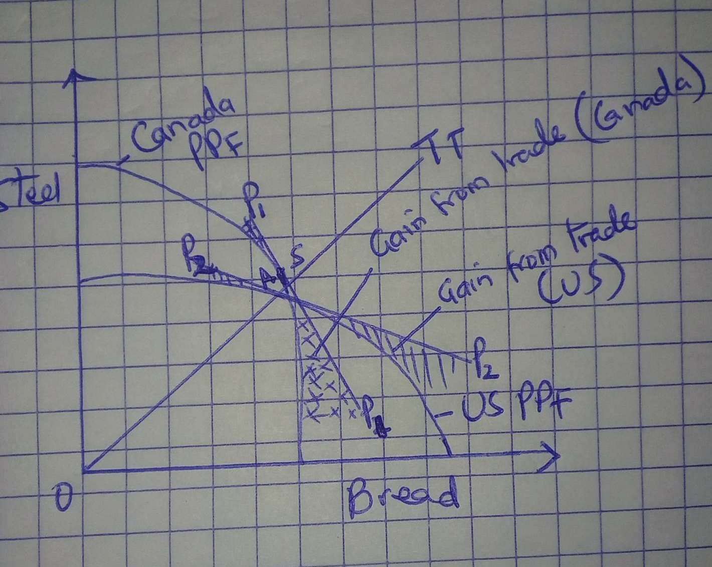

Figure 7.0

Question Eight
Variable factors: Labour
Specific factors: Land and capital

